Civil war in Liberia

UNSC Resolution: | 1408
Date of adoption: | 6-May-2002
Operative paragraph: | 11
Demand number: | 1408,1111

Sarah-Myriam Martin-Brûlé

Wording of demand

support United Nations efforts to verify all information on compliance which is brought to the United Nations notice

List of addressees of the demand

Government of Liberia

Short-term compliance

Description of the addressee(s)’ conduct

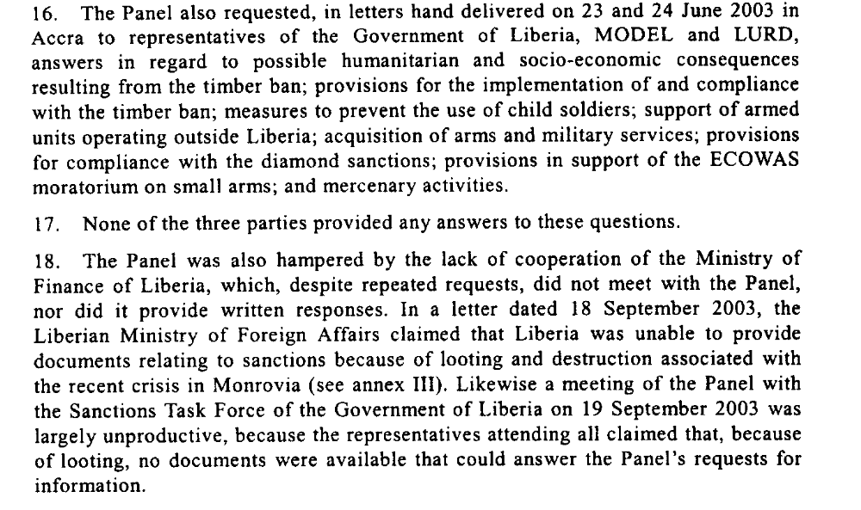
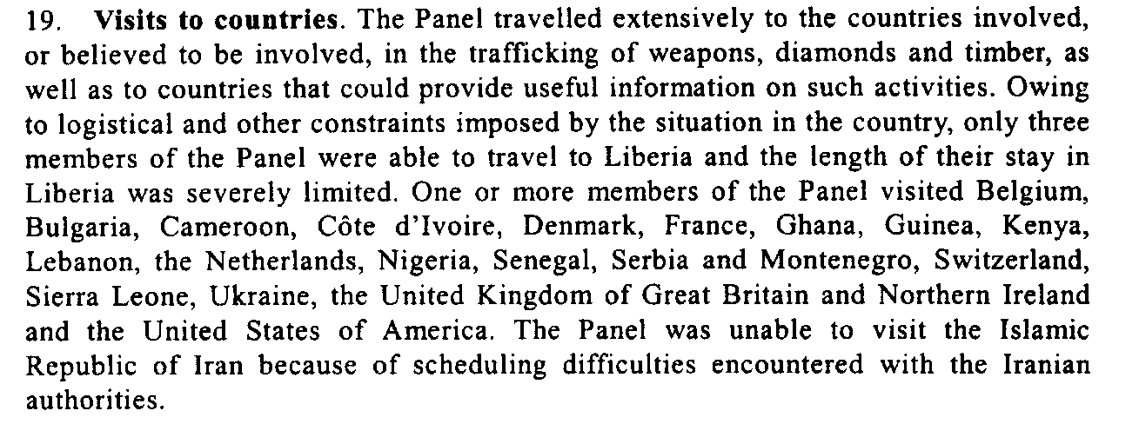
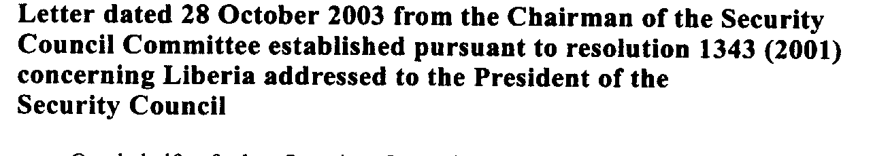

18. The entire six-member Panel met for the first time on 14 June 2003 in New
York. The consultant for humanitarian and socio-economic aspects joined the Panel
in Abidjan. Significant time constraints and security restrictions in Liberia limited
the Panel’s investigation. In addition, insufficient credible data on Liberia’s timber
industry as well as on the country’s humanitarian and socio-economic situation has
hampered the investigation.
Letter dated 7 August 2003 from the Acting Chairman of the Security Council Committee established pursuant to resolution 1343 (2001) concerning Liberia addressed to the President of the Security Council

Assessment

Short-term compliance
No or marginal compliance (1) | X Medium low compliance (2) | Medium high compliance (3) | Full or almost full compliance (4)

Considerations underlying the assessment

Within the six months following the adoption of the demand, the government of Liberia marginally supported United Nations efforts to verify all information on compliance which is brought to the United Nations notice.

Medium-term compliance

Description of the addressee(s)’ conduct

“3. On 6 November 2003, I addressed a letter to the President of the Security
Council informing him that, because of the prevailing situation in Liberia, which
had necessitated the evacuation of United Nations personnel, It had not been
possible to gather the information needed to prepare the report and advising of the
need to defer the submission of that report until early 2004, in order to allow the
United Nations Mission in Liberia (UNMIL) and the National Transitional
Government ample time to gather the requisite information and to conduct an
assessment of the new circumstances on the ground, with a view to providing inputs
that would enable me to prepare the report.”

Report of the Secretary-General pursuant to Security Council resolution 1478 (2003) regarding Liberia, 1 April 2004

Assessment

Medium-term compliance
No or marginal compliance (1) | X Medium low compliance (2) | Medium high compliance (3) | Full or almost full compliance (4)

Considerations underlying the assessment

Within the two years following the adoption of the demand, the government of Liberia marginally supported United Nations efforts to verify all information on compliance which is brought to the United Nations notice

Depth of demand

Assessment

Level of depth of demand
Low depth of demand (1) | X Medium depth of demand (2) | High depth of demand (3)

Considerations underlying the assessment

The government of Liberia could not “support United Nations efforts to verify all information on compliance which is brought to the United Nations notice”, since evidence existed that members of the government were involved in violations of the Security Council Resolution.

“The corrupt system established by the former President Taylor continued under the NTGL. For many officials in the NTGL and former combatants, the incentives to be involved in illegal and corrupt practices were far more lucrative and therefore attractive then the incentives to work towards peace and democracy. This prevented any real changes in the management of the country from taking place.”
Teran, Nika Stražišar. 2007. “Peacebuilding and Organized Crime: The Cases of Kosovo and Liberia” Working Paper. Swiss Peace Foundation.
http://www.swisspeace.ch/typo3/fileadmin/user_upload/pdf/Working_Paper/WP_1_2007_Kosovo_und_Liberi_neu.pdf

Level of confidence about coding decisions

Level of confidence about coding decision
Extremely high | X High | Moderate

Comments to IPI (if any)

